**Laquipampa**

***Summary:***

• Location: Lambayeque Region  
• Climate: Dry, warm and sunny  
• Attractions:  
                 - Beach Puerto Eten, Beach Santa Rose, Pimentel, Beach San José

***Important details:***

* Duration: about 9 hours
* Including:  
  - Private transport  
  - Lunch with fish

- Leadership

**Itinerary:**

We start the tour by the beach Puerto Eten which is about 22km (30 min.) away from Chiclayo. This sandy beach is cheap and has a high tide. Through the really nice marine fauna the place looks even better. You can do more than just enjoy the beautiful sunny day at the beach, you can enjoy water sports such as surfing and adventure sports. There are also hiking and camping packages. Here you can take very nice pictures.

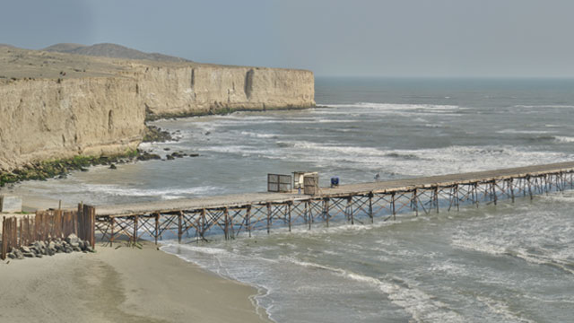

**Charge: Price/per person**

|  |  |
| --- | --- |
| **Pupil** | **40.00 Soles** |
| **Student** | **50.00 Soles** |

* For every 15 Member there is the trip for free

Useful information:

* What do I take with me?  
  Sunscreen, sunglasses, camera, hat, light clothing, wind jacket, comfortable shoes and money, especially for those who want to buy local crafts
* Contact:   
  Tel 074 203922  
  cel 979014584  
  Web: ecoserv24.wix.com/ecoserv  
  E-mail: ecoserv24@gmail.com

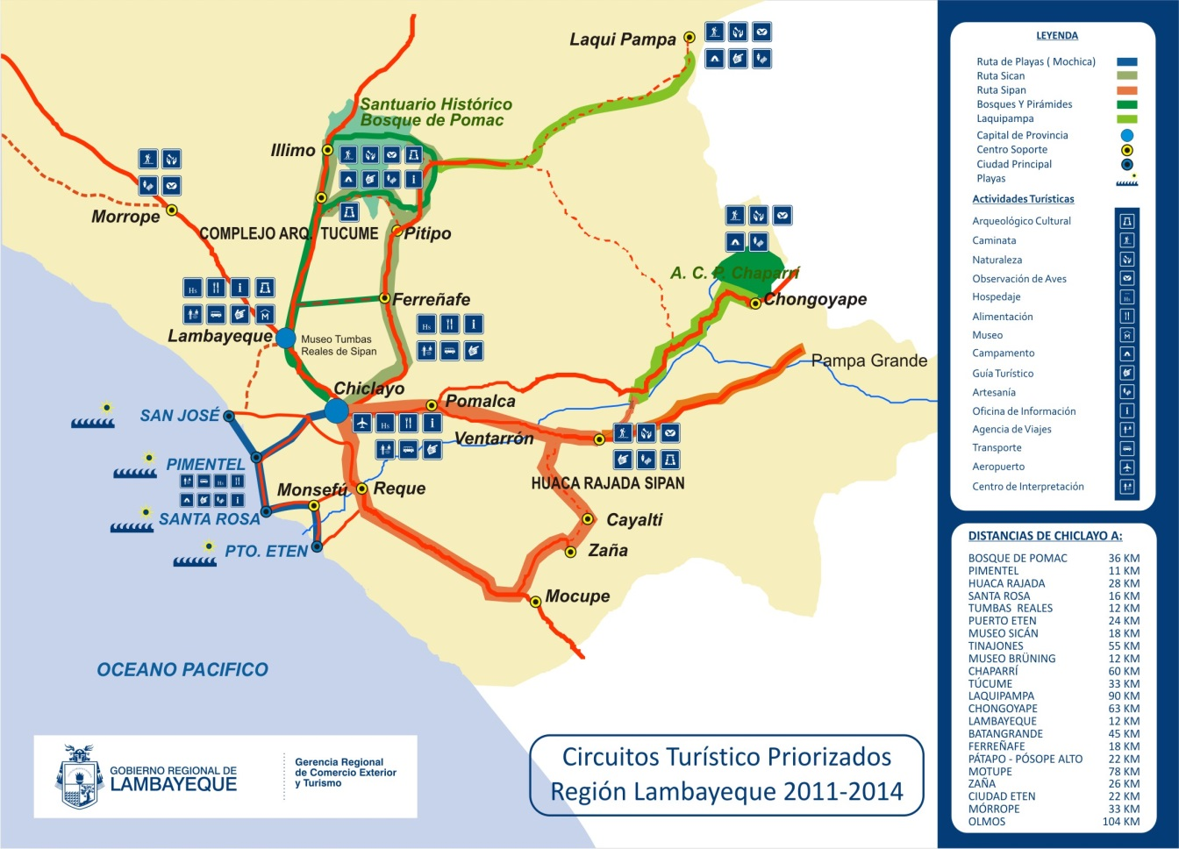***Map of the area:***