**Laquipampa**

***Summary:***

• Location: Lambayeque Region  
• Climate: Dry, warm and sunny  
• Attractions:  
                 - Laquipampa wildlife  
• Tourist facilities: history, archeology and ecotourism

***Important details:***

* Duration: about 9 hours
* Including:  
  - Private transport  
  - Lunch with the community  
  - Leadership

**Itinerary:**

It is a "must" from Chiclayo Batangrande to go to Bosque de Pomac. This place is appreciated because of its ancient trees and its multifold wildlife.

Then we go to Laquipampa, but make a stopover in Mayascón to visit "Jagüeyes". Here you cann see how a small drop of water can change to a form of a small waterfall. There are many species and lush flora now.

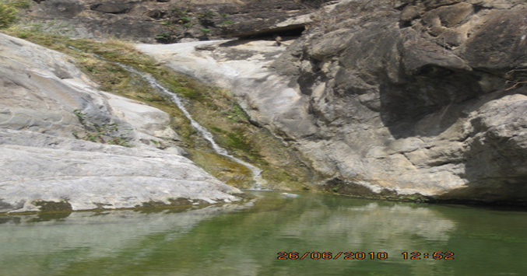

Continue the tour and then we will make a stop in Laquipampa for lunch and to be able to take a break.

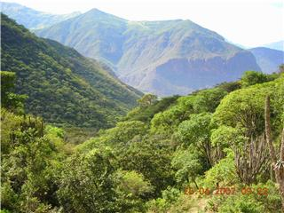

Then we visit the waterfall, which is located in Laquipampa and allows a breathtaking view.

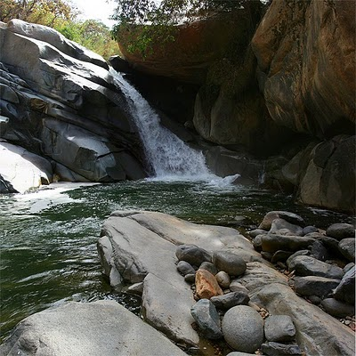

Then we go into the jungle. Here you can observe some Pavas Aliblancas and Pava Parda. Besides that you can hike and take pictures / videos.

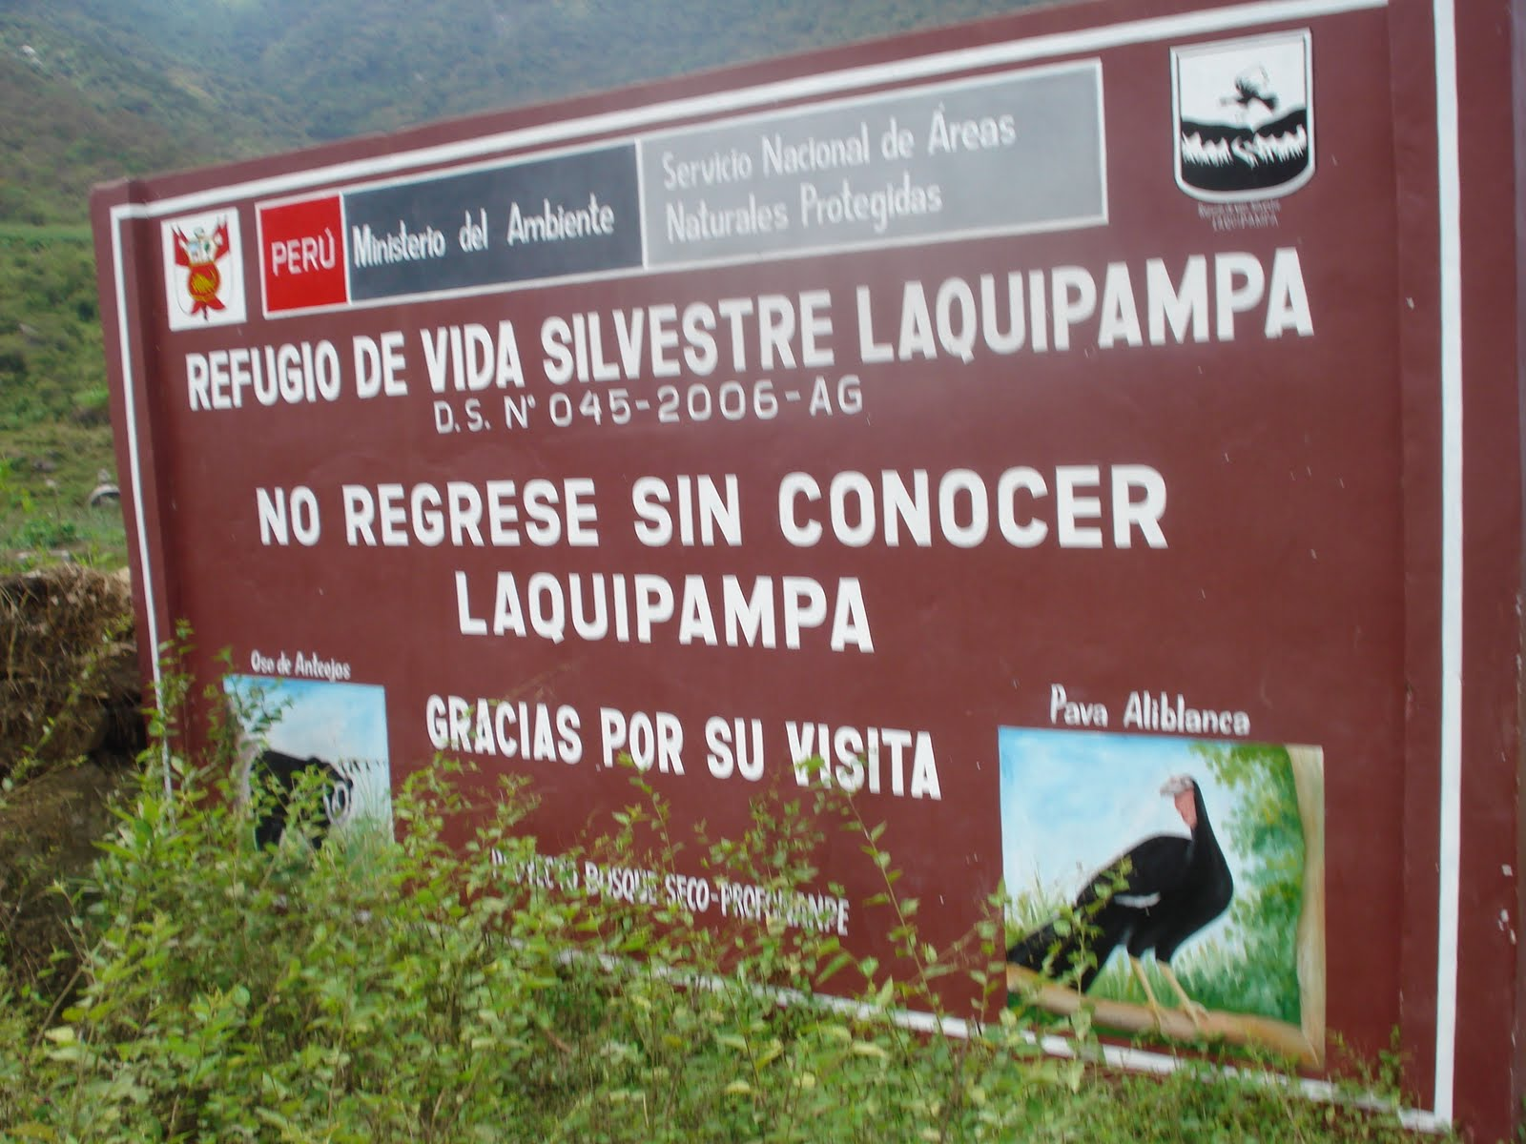

**Charge: Price/per person**

|  |  |
| --- | --- |
| **Pupil** | **40.00 Soles** |
| **Student** | **50.00 Soles** |

* For every 15 Member there is the trip for free

Useful information:

* What do I take with me?  
  Sunscreen, sunglasses, camera, hat, light clothing, wind jacket, comfortable shoes and money, especially for those who want to buy local crafts
* Contact:   
  Tel 074 203922  
  cel 979014584  
  Web: ecoserv24.wix.com/ecoserv  
  E-mail: ecoserv24@gmail.com

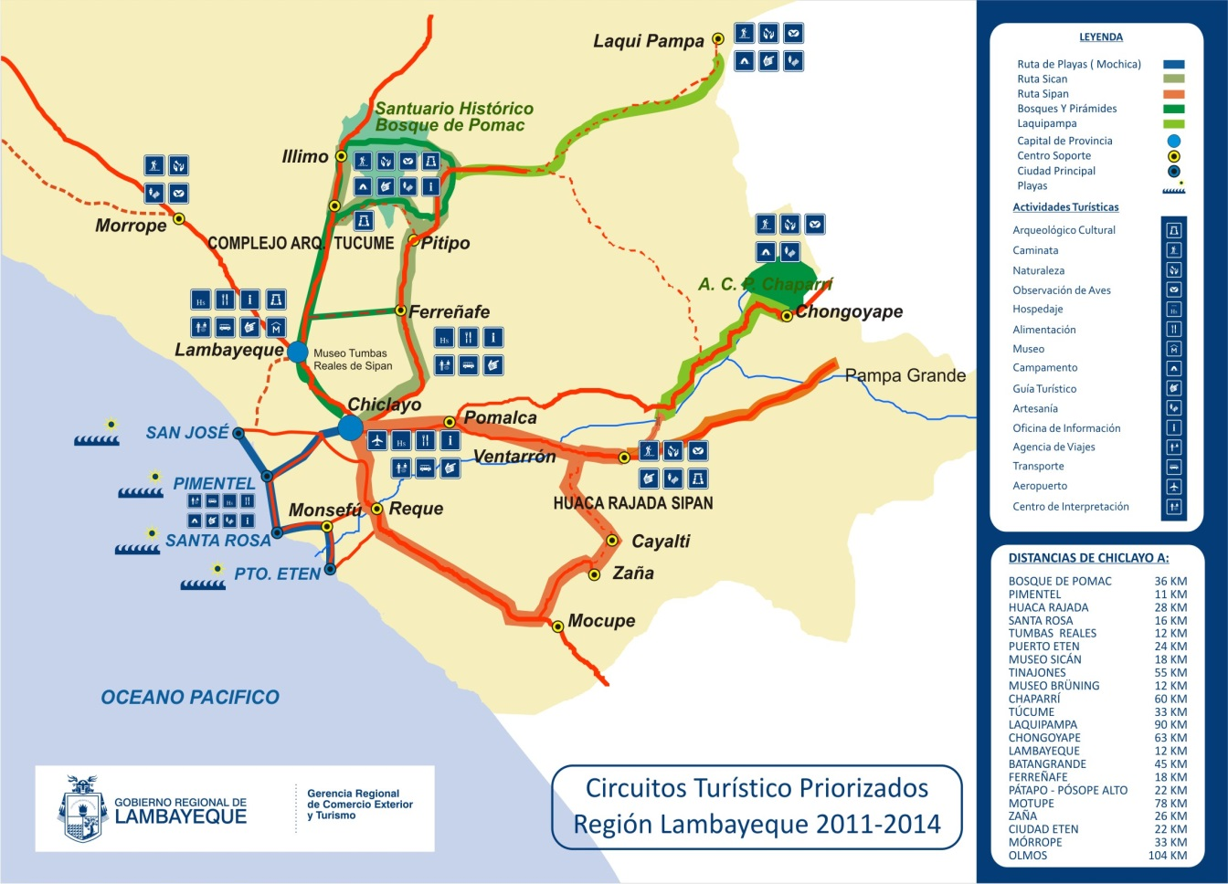***Map of the area:***