**The Route of the pyramids and woods**

***Summary:***

• Location: Lambayeque Region  
• Climate: Warm to moderate  
• Attractions:  
                 - Museum: Túcume  
                 - Culture of life: food, crafts  
• Tourist facilities: history, archeology and ecotourism

***Important details:***

* Duration: about 9 hours
* Including:  
  - Private transport  
  - Lunch with the community  
  - Leadership

**Itinerary:**

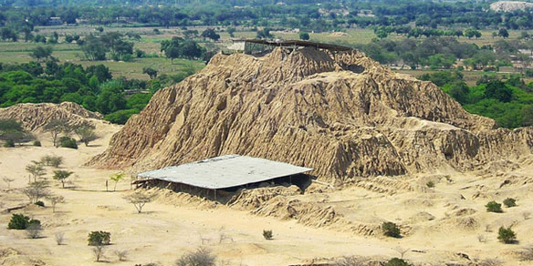We begin with a visit to the Pyramids and the forest with an overview of Huaca el Pueblo de Túcume and Huaca Manuelón, which is located 35 km from Chiclayo (45 min.). You will appreciate the access to the main building, the internal departments or specific architectural features. Here is a building with characteristic lateral furrows damaged by torrential rains, which is caused by the El Niño phenomena.  
After the expedition we will visit the Huaca Las Balsas, a religious temple for the worship of water. This temple was ruled by women. There is also another route where you go to the museum first and then go to the center of the "Nancolamp" which is also at Huaca.

Then we will take a break for a snack to eat.  
  
After that we visit the museum "Sitio de Túcume", which is located in the same named district. This museum shows the development of the Lambayeque culture. The valley consists of 26 pyramids. The first called Huaca is “Mirador” which is very interesting because there has a beautiful panoramic view. You have to climb the pyramid first thou of course be ready.  
  
Here also crafts are provided by a diverse range of products in various techniques such as weaving were made. Besides these, there are gold, jewelery and ceramics to buy. There is also a playground

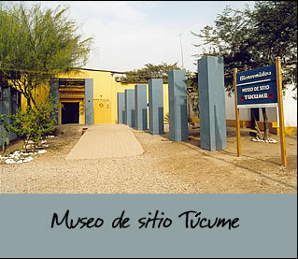

Then we go back to Chiclayo.

**Charge: Price/per person**

|  |  |
| --- | --- |
| **Pupil** | **40.00 Soles** |
| **Student** | **50.00 Soles** |

* For every 15 Member there is the trip for free

Useful information:

* What do I take with me?  
  Sunscreen, sunglasses, camera, hat, light clothing, wind jacket, comfortable shoes and money, especially for those who want to buy local crafts
* Contact:   
  Tel 074 203922  
  cel 979014584  
  Web: ecoserv24.wix.com/ecoserv  
  E-mail: ecoserv24@gmail.com

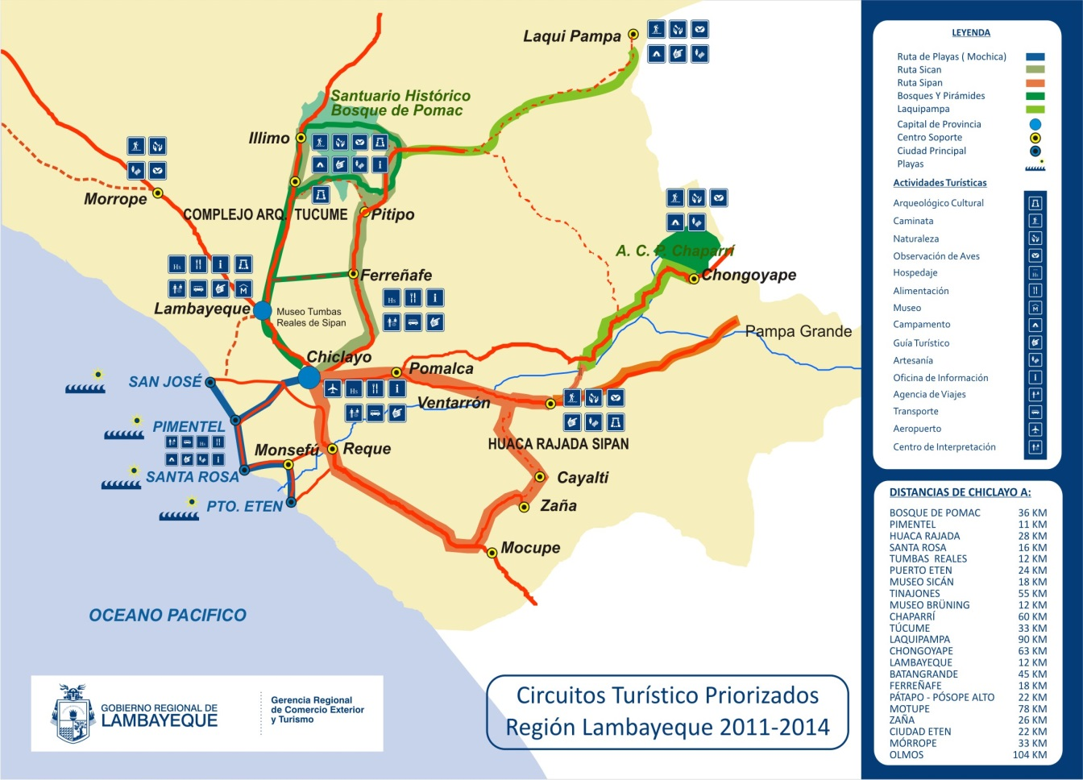***Map of the area:***