**The Route of Sipán**

***Summary:***

• Location: Lambayeque Region  
• Climate: Warm to moderate  
• Attractions:  
                 - Archaeological and Historical Complex: Archaeological Gale, Sipan Archaeological

Complex, Sipan Craft Complex

- Museums: Museum of Sipan site - Sipan Royal Tombs of Sipan Museum Afroperuano.

- Churches: St. Augustine Convent, San Francisco Church, La Merced Church, Mother

Church

• Tourist facilities: History, archeology and ecotourism

***Important details:***

* Duration: about 9 hours
* Including:  
  - Private transport  
  - Lunch (menu)

- Entrance tickets for the museums  
- Leadership

**Itinerary:**

We begin the tour with a visit to the Archaeological Complex Gale, which is located 4 km from Pomalca and 11.5 km. from Chiclayo (20 min.). There you can see its extraordinary architectural design that shows the greatness and genius of the ancient inhabitants of northern Peru. Furthermore, captivate with colorful murals that decorate several of the most important rooms of the temple, as an enclosure cruciform (chacana) which was newly discovered. Besides, you are allowed to take pictures or/and videos.

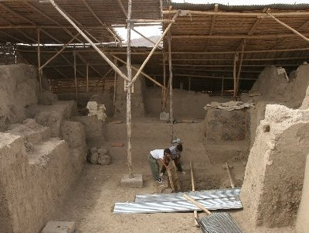

Then we go to the district of Zana, to visit the archaeological complex Sipan. At this place are two adobe pyramids and a burial platform. In 1987, the burial chambers of the nobility who ruled in the Moche valley between the second and third centuries AD, were discovered. You can see the precise installed environments where tombs were discovered of the Lord of Sipan, the Priest and the Old Lord of Sipan. In addition to its majestic flora and fauna, you can perform other cultural and research activities. You can take pictures or / and videos. The journey lasts about 2 hours.

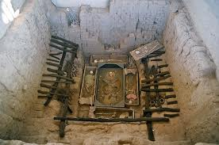

Continuing the route, we visit the Museum of Sipan, which exposes more than 40 original pieces of Moche tombs. This place is 2 min Sipan Archaeological Complex away. Here you can observe cultural evidence and Noble Warrior Priest records and post Mochica Mochica (Chimu, Lambayeque, Inca). In addition, the exterior shows the recreation of different architectural phases of the pyramids. Inside the museum is prohibited to take pictures and videos, unless you have a permission. There is a food service, disabled facilities, restrooms and safety.

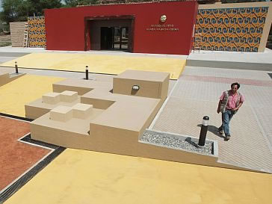

Afterwards we go to the Sipan Craft Complex, which is located on the opposite site of the Sipan Museum. It has 5 rooms fully suitable for the manufacture of products and main auditorium where visitors can observe and participate the process of manufacture and preparation of products made by locals. You are allowed to take pictures or / and videos.

Then we will stop for lunch and continue the tour.

Now we will visit the churches that make up the Zaña attraction. We start with the San Agustin Convent, which is the most valuable architectural work. Then the Church of San Francisco, La Merced Church and the Mother Church. The mother church is made out of a basilica type, with a high central nave and two lower side chapels.

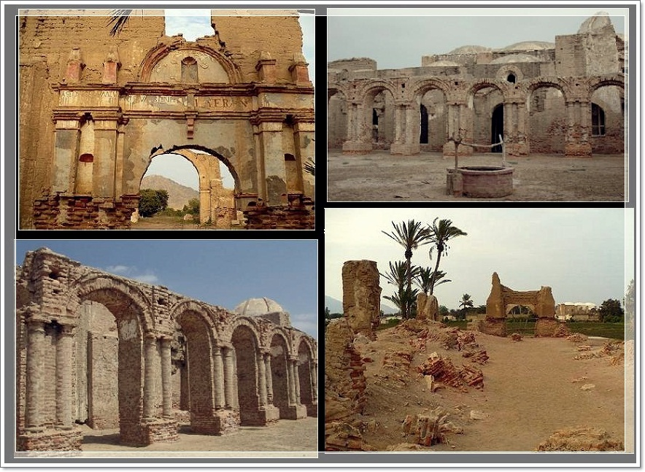

Then we visit the Afro-Peruvian Museum of Zana, where you can see various topics such as ethno history, art, music, dance, torture, labor and production in several showrooms. All this is interpreted through photographs, paintings, handcrafted pieces, musical instruments, costumes and a series of objects that show the richness of our history. The travel lasts 1 hour.

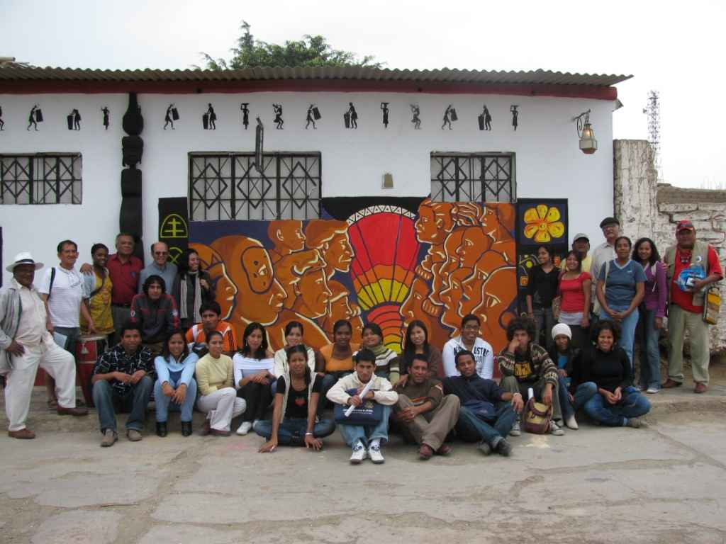

To complete the beaten track, we go towards the majestic Royal Tombs of the Sipan Museum. Housed inside are the remains of the Lord of Sipan. In the museum you can buy handicrafts or information material, restrooms are available and they have handicap facilities. To take pictures or record videos is strictly prohibited inside the museum.

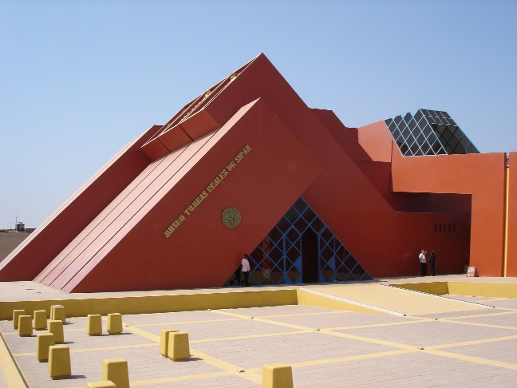

Finally, we return to Chiclayo and visit the factory San Roque, which is dedicated for the traditional sweets of our region. There you can see the process of development and also have the opportunity to taste and buy some of them.

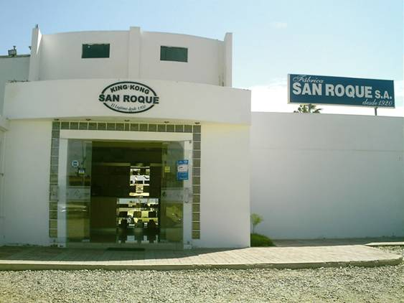

Then we go back to Chiclayo.

**Charge: Price/per person**

|  |  |
| --- | --- |
| **Pupil** | **40.00 Soles** |
| **Student** | **50.00 Soles** |

* For every 15 Member there is the trip for free

Useful information:

* What do I take with me?  
  Sunscreen, sunglasses, camera, hat, light clothing, wind jacket, comfortable shoes and money, especially for those who want to buy local crafts
* Contact:   
  Tel 074 203922  
  cel 979014584  
  Web: ecoserv24.wix.com/ecoserv  
  E-mail: ecoserv24@gmail.com

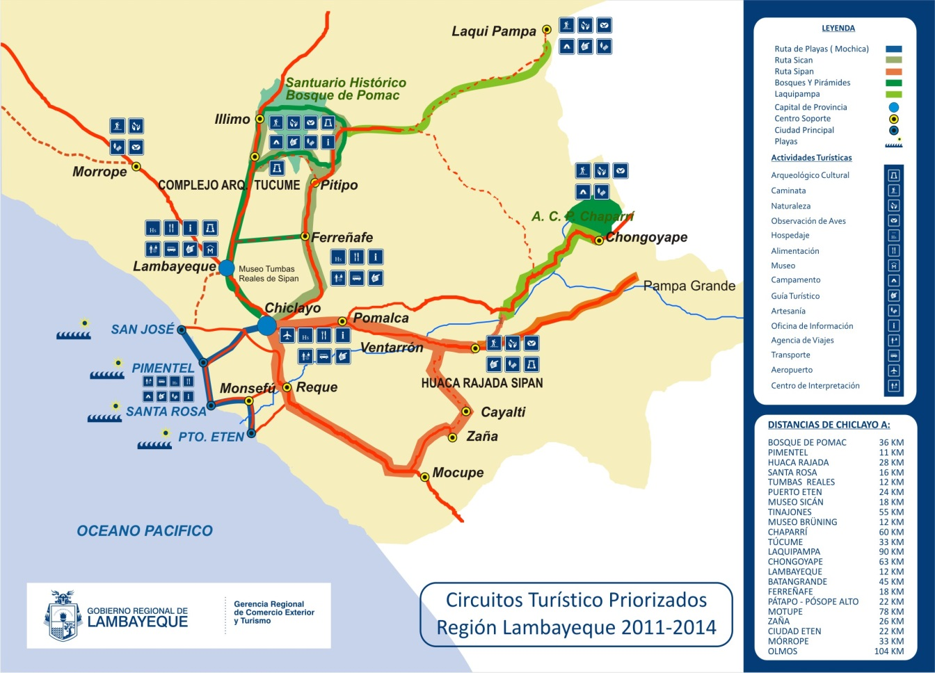***Map of the area:***