**The Route of Sicán**

***Summary:***

• Location: Lambayeque Region  
• Climate: Dry, warm and sunny  
• Attractions:  
                 - Museum: Nacional Sicán y de Sitio de Túcume  
                 - Natural shrine: Bosque de Pomac  
• Tourist facilities: history, archeology and ecotourism

***Important details:***

* Duration: about 9 hours
* Including:  
  - Private transport  
  - Lunch

- Drink  
- Leadership

**Itinerary:**

We start the tour "Sicán" with a visit to the National Museum of Sican, which is in the province Ferreñafe and about 19 km. (20 min.) away from Chiclayo. Here you can see the remains of the original ornaments and Sican the Lord.  
In the museum you can buy handicrafts, get more information at the office and there are restrooms that are handicapped accessible.

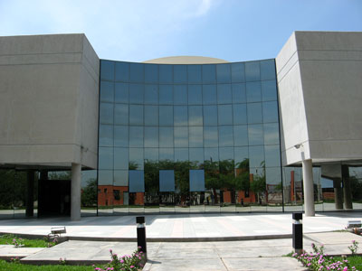

After the tour we will visit the Bosque de Pomac Historic Sanctuary, which is located in the district Pitipo.  
  
At this point, you will assess the value of the ancient trees, the Mirador Las Salinas, La Casa beekeeping Karl Weiss, gold and Huaca Huaca Las Ventanas. You can also buy natural products derived from the dry forest. Those are produce from the people of the region. Included are also the carob tree, pollen honey, mead and honey. You can also experience the reforestation and forest protection up close. You can go riding, hiking or biking and do other cultural activities  
  
Visit the Huaca de Piedra Ecolodge, which is only a few minutes away from Pomac.

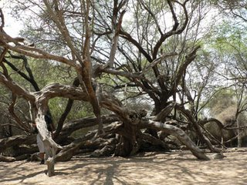

Then we go back to Chiclayo.

**Charge: Price/per person**

|  |  |
| --- | --- |
| **Pupil** | **40.00 Soles** |
| **Student** | **50.00 Soles** |

* For every 15 Member there is the trip for free

Useful information:

* What do I take with me?  
  Sunscreen, sunglasses, camera, hat, light clothing, wind jacket, comfortable shoes and money, especially for those who want to buy local crafts
* Contact:   
  Tel 074 203922  
  cel 979014584  
  Web: ecoserv24.wix.com/ecoserv  
  E-mail: ecoserv24@gmail.com

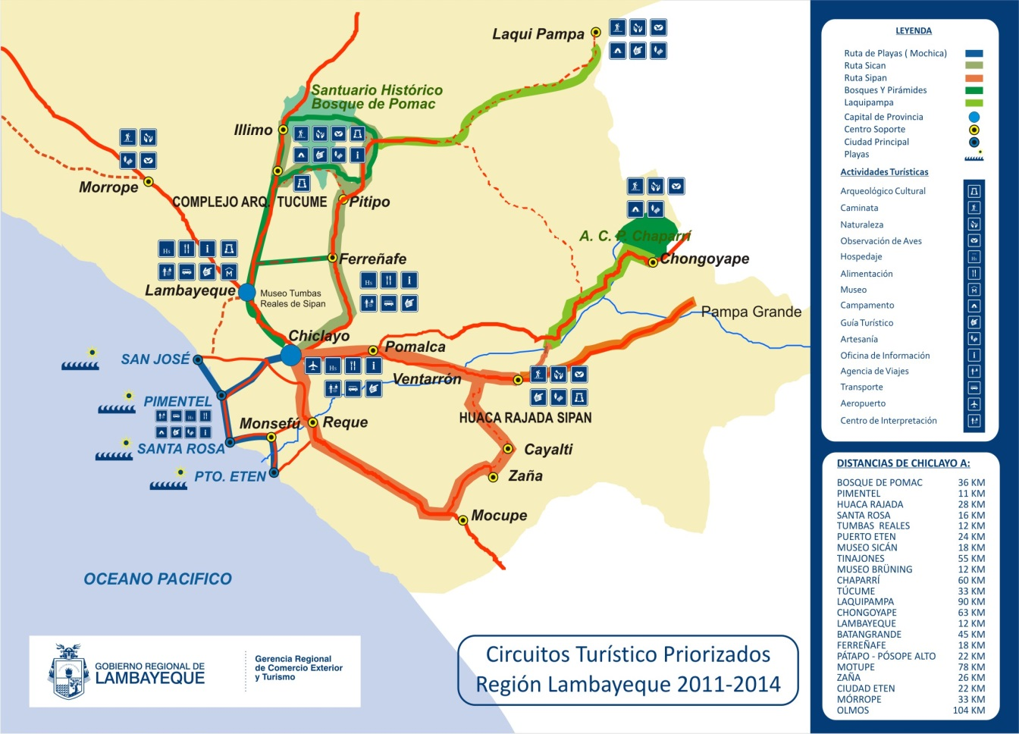***Map of the area:***